Ideation Phase
Define the Problem Statements

Date | 02 july 2026
Team ID
Project Name | Sports Hall Booking System using Service Portal (ServiceNow)
Maximum Marks | 2 Marks
Customer Problem Statement Template:
Create a problem statement to understand your sports hall users' and facility administrators' points of view. The Sports Hall Booking System problem statement helps you focus on what matters to create seamless, automated reservation experiences that facility users will love.
A well-articulated booking problem statement allows you and your development team to find the ideal solution for the scheduling, allocation, and administrative challenges your customers face. Throughout the process, you’ll also be able to empathize with your court bookers and service desk staff, which helps you better understand how they perceive your sports facility management service.

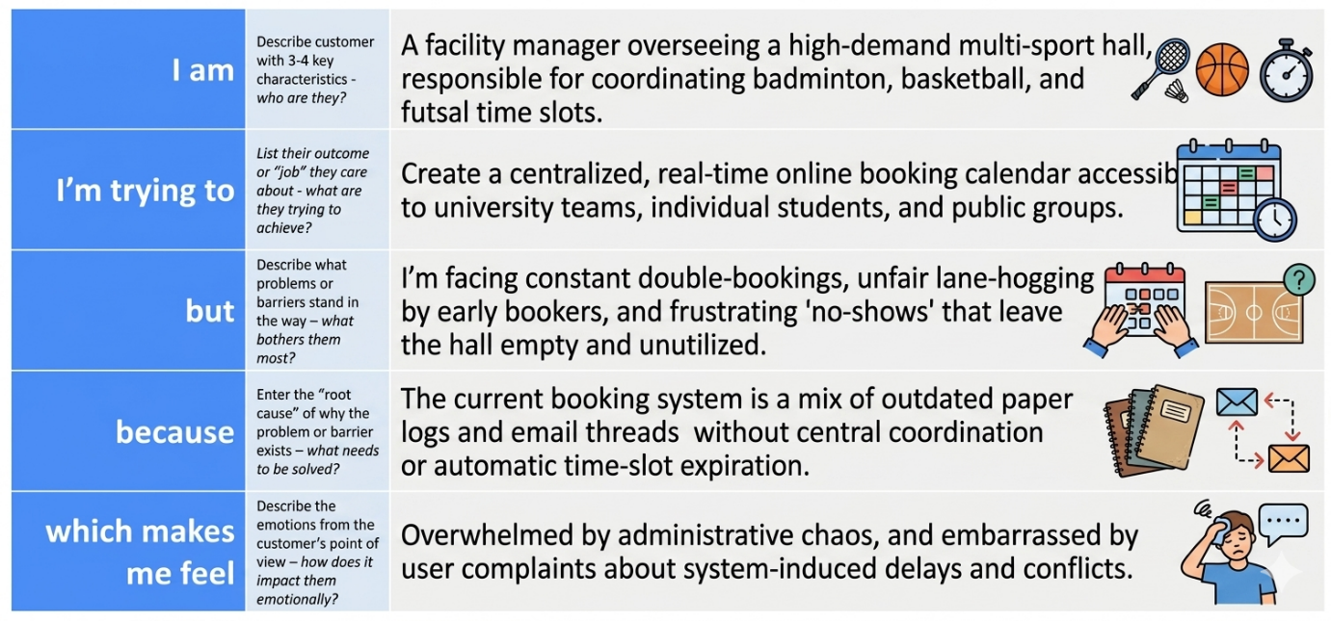
Example:
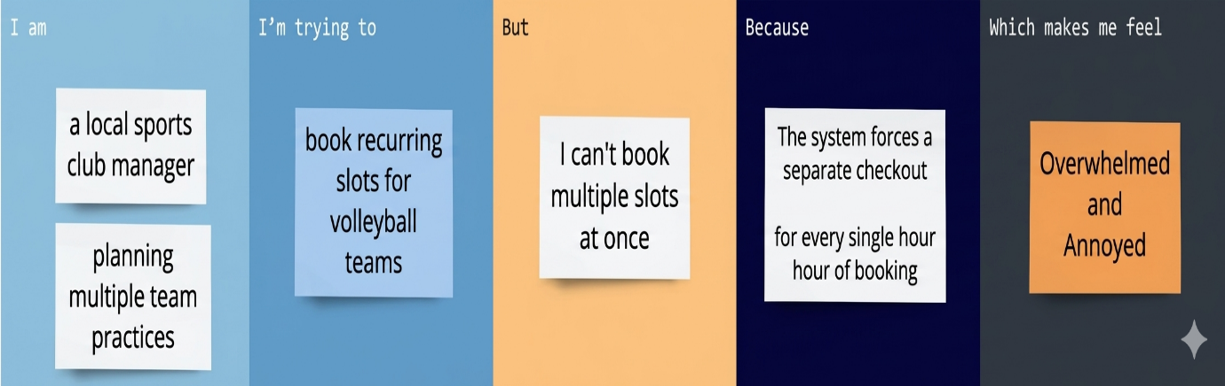
Problem Statement (PS) | I am (Customer) | I’m trying to | But | Because | Which makes me feel
PS-1(user) | A university student or sports club team manager | Book recurring practice slots for my team every week | I cannot view real-time court availability or book multiple time blocks at once | The system relies on outdated email logs and manual, slow reservation confirmations | Frustrated and annoyed due to delayed planning and lost field time
PS-2(admin) | A ServiceNow Facility Administrator | Automatically manage schedules, coordinate courts, and prevent double-bookings | I have to spend hours resolving overlapping schedules and managing "no-shows" | The current application lacks automated validation rules and check-in constraints | Overwhelmed and stressed by constant user complaints and system chaos

